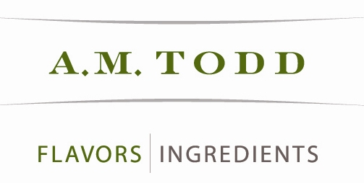 PRESS RELEASE

FOR MORE INFORMATION
Charles Dodson
269-216-2613
cdodson@amtodd.com

- M. Todd Acquires Moore Ingredients
Organic Ingredients Compliments Flavors and Ingredients Portfolio
KALAMAZOO, MI, March 23, 2007 - A. M. Todd strengthened its ingredients portfolio today with the acquisition of Moore Ingredients. Moore Ingredients, based in Hamilton, Ohio, creates and manufactures natural and certified organic specialty ingredients. Going forward it will operate as a division of A. M. Todd., which focuses on the oral care, confectionery and beverage industries. This new combined entity can better serve the organic market and organic needs of existing customers. As of the date of the agreement, March 23, 2007, Moore Ingredients has been in business 15 years and A. M. Todd 138 years.
“A. M. Todd is delighted that the creative skills of our two companies will be joined so that we can better serve our customers. We consider this a continuation of the growth and development of the A.M. Todd Group.” stated Henry W. Todd, Chairman and CEO.
The synergies of the two companies are expected to provide a strong platform for growth. Both companies are family run businesses with common values. Diana Moore offered, “Moore Ingredients’ core values as a family company and our dedication to the natural products category, has remained intact throughout the changes to the landscape of the flavor industry. I'm proud that A. M. Todd, an organization with such a similar history that shares these values, will now navigate Moore Ingredients’ continued growth.” Instrumental in the deal, Tony Moore comments, “Increased development capabilities will provide greater solutions for customers and deliver the opportunities for growth and innovation.”
Ray Hughes, President of the Flavors & Ingredients Division adds, “We are excited to be working with Tony Moore. This acquisition allows us to leverage the expertise and creativity that Moore Ingredients brings through the global reach of A.M. Todd”
A. M. Todd will manage sales and operations broadening the existing Moore customer base and the new division will allow A. M. Todd to provide organic ingredients to the trade industries it serves.
-more-
About A. M. Todd
For more than 138 years, A. M. Todd has stood for resourcefulness in agriculture, flavor technology, and product development. A. M. Todd is a global company and a natural resource for flavors used in the confections, gum and oral care industries. Its botanically-based products provide value-added ingredients for the diet supplement and functional food industries, as well as in health and wellness products. For more information go to www.amtodd.com
About Moore Ingredients, Ltd.
Based in Hamilton, Ohio, Moore Ingredients, Ltd. creates and manufactures natural and certified organic specialty ingredients. Since the company’s inception, fifteen years ago, Moore Ingredients focus has been on natural products with an innovative and entrepreneurial spirit grounded in family values. As the natural product industry has grown into organics with an awareness of social responsibility, Moore Ingredients has grown along with it. Moore Ingredients supplies superior service and the highest quality products. For more information go to www.moorelab.com.
###

